

Faculty of Engineering

Department of Electronic Engineering

|  |  |
| --- | --- |
| **Name** | Francois Mavunila |
| **Student Number** | N0172507W |
| **Project Title** | Taxi safety and robbery prevention system |
| **Supervisor** | Mr. B. Dlodlo |

**ACKNOWLEDGEMENT**

I would like to thank everyone who helped me in doing this project from start to end, special thanks to my project supervisor Mr. B Dlodlo for giving me a chance and guidance in doing this project. I would also want to give thanks to my friends and family who supported me with the finances to complete my project.

**ABSTRACT**

Taxis are of use in our day to day lives, they help carry people from one place to another especially in areas which are not in the route of Kombis and Buses, but there has been a concern with the rise of taxi related robberies in the country. Both passengers and drivers fall victim of such incidents and it has been noted that usually the robbers use the same vehicle to rob different people in different places of the city and the police find it difficult to trace the robbers and in some cases the victims are found dead and dumped after some days of efforts in trying to find them. Most of these robberies happen at night where the victim cannot identify the robbers and the vehicle plate number and hence investigations become difficult and the same robbers usually victimize a number of people. Therefore, the purpose of this project is to develop a system that will help in robbery investigation in taxi related robberies.

The whole objective of this project is to develop a device, using a raspberry pi board and a microcontroller board that will allow the driver and the passengers to authenticate their taxi ride using their fingerprints. The fingerprints will be kept in a secure database and used for investigation in case of any robbery.

This system used a raspberry pi board and an esp32 microcontroller board to capture and send fingerprint data to a centralized database (registrar database). The information was sent via MQTT communication protocol and a web application was added to the system to monitor the activities and manage users and the database.

Testing of the system was done using a number of selected individuals and the results showed that the system could be used in real life situation in Zimbabwe.

The project is easy to install and use and does actually help in investigating robberies and even reducing robberies.

Table of Contents

1 LITERATURE REVIEW 3

1.1 Introduction 3

1.2 Public transport industry 3

1.2.1 Transport Industry World wide 3

1.3 Conclusion 8

2 System Design 9

2.1 Introduction 9

2.1.1 Overall System Block Diagram 9

2.2 Design of System Modules 10

2.2.1 Taxi-ride authentication system 10

2.2.2 Design of the Server and database 13

2.2.3 Design of the database 20

3 References 22

Figure 1-overall system block diagram 14

Figure 2-taxi ride authentication system 15

Figure 3-taxi-ride-flowchart 16

Figure 4-interrupt service routine for panic buttons 17

Figure 5-super user usecase diaram 19

Figure 6-registrar admin usecase 19

Figure 7-third party registrar usecase 20

Figure 8-server request handling 21

Figure 9-differentiating admins 22

Figure 10-Flow chart showing how the server will handle searches 22

Figure 11-obtaining investigation data 23

Figure 12-the server design for handling request for taxi ride 24

Figure 13-database design 25

# INTRODUCTION

## Introduction

This chapter provides an introduction to the project topic, the chapter discusses the project background, problem statement, objectives and the project scope.

## Background

Taxis play an important part in the transport industry worldwide. Taxis increases mobility, they allow for prompt pick-up and drop off, they are convenient and offer a 24/7 service, they are very helpful to people who have disabilities and the elders and they are relatively cheap. The taxi industry provides employment to a large number of people and most of them are self-employed. Closely related the taxi transportation system is the rise of the ride-sharing services which are offered by companies such as Uber, LYFT and via. In ride-sharing services, drivers connect with passengers via a website or mobile application and drivers carry passengers to their destination for a fee which they may receive electronically.

#### In Zimbabwe the public transport sector comprises of publicly owned transport buses and privately owned mini-buses, and taxis. ZUPCO ([Zimbabwe United Passenger Company](http://www.zupco.co.zw/)) is the only government owned public transport company.  Most people, however, use privately-owned commuter minibuses.  These Minibuses don’t have published schedules or routes, but are widely used. Non-published routes and schedules are learned by local commuters. [1] Most taxis are privately owned and are registered under different private taxi associations such as Gibela Taxis, Expricos, [Centrust Travel](https://www.zimbabweyp.com/company/2238/Centrust_Travel), [and City Line Taxis](https://www.zimbabweyp.com/company/4119/City_Line_Taxis). Apart from these registered taxis, Zimbabwe also has seen a rise in the number of privately owned personal cars getting into the public transport industry without registering with any public transport authorities. Most of the people involved in such business are owners of Honda fit and Toyota wish. Zimbabwe has seen an introduction to the ride sharing services some years ago, but the majority of the people are reluctant to use the services due to the economic situation and some other reasons. However there is still a certain group of people who use the services, especially foreigner and those in the upper class in the country.

Given the nature of the taxi service sector, a lot of issues pertaining to safety are rising. Taxi drivers have been reportedly hijacked, robbed and in some cases killed due to the fact that they work during the late hours and even during the day they are sometimes asked to carry people to secluded areas and robbed in those areas. The situation affects both drivers and riders as in some cases drivers take advantage of the rider’s conditions at night or when they are drunk. The introduction ride-sharing services has seen a rise in the security concern all over the world. There have been a lot of report of drivers being robbed or hijacked. In these incidents, the offenders would arrange a rideshare trip on their mobile application and would rob or hijack the victim during or after the trip and in most of these incidents the offenders would be armed [2]. Passengers face the same situation with the ride-share services, reports show that a in a number of cases the robbers have posed as uber drivers and robbed passengers of their valuables, in some cases the passengers are sexually abused, especially females. In Zimbabwe there are a number of crimes that are taxi related, one article reads, “A number of robberies, rapes and thefts have occurred where victims fall prey to the illegal transporters who present themselves as genuine transporters” [3].

There are number of measures that have been put in place in trying to reduce taxi related crimes. Uber introduced a system to share your location with your friends and your relatives, and a system of aliveness detection using cameras. These systems have help to reduce the crime to some extent, but in cases where the rider have their smart phone taken away or their battery dies their security is totally at risk. In Zimbabwe the Vaya Africa app includes features such as verification of the driver’s vehicle number plate, letting your friends know your route and also a panic button in case of a suspicious activity [4]. The challenge is that there is a considerable number of people who own a smart phone in Zimbabwe and those who own it are reluctant to using such systems. Using software or mobile app based solutions poses a challenge as these solutions are not applicable to taxicabs and to private car owners who might want to give someone a ride. The Zimbabwean police face a challenge in solving these cases due to the lack of criminal’s identity, information and enough evidence.

This project brings a solution to the taxi related crime through capturing the driver’s and the passenger’s fingerprints during a ride and storing them in the registrar database. The system ensures safety for anyone who needs to ride a taxicab or use a ride share even if they don’t have their smart phone. The solution includes a device (hardware) that will be used to capture and send the passenger’s and the driver’s fingerprint to the registrar database and the details of the start and end of the trip for each customer. This will provide enough data for the police in case of any crime.

## Problem Statement

Taxis contribute a lot in the transport industry and people use them on a daily basis because they are cheap, allow for mobility and can reach almost anywhere, however there is an increase in the number of taxi related crimes and there is lack of authentication and robbery data to help in investigating the taxi related crimes. In most cases the driver or the passenger fails to identify the robbers that is if they are left alive, in some cases dead bodies are found and details of which taxi the deceased was in, are not found.

## Aim

To develop a system that keeps track of the identity of the passengers and the taxi drivers during a trip by recording and uploading the driver’s identity and every passenger’s identity, the time the driver and the passenger were together and the time the driver and the passenger went separate, to the General Registrar database.

## Objectives

* To establish the development of a system to register the taxi driver’s vehicle registration number, address, Name, Id number, Driver’s License number and the finger print to a database.
* To read the passenger and drivers identity using a figure print scanner
* To send the finger print Ids to a remote server for processing and storage in the database.
* To develop a program that checks whether the driver is registered and authorized.
* To develop a system that checks that the passengers are in the taxi using weight sensor and give the number of passengers.
* To register passenger’s fingerprint upon arrival at their destination and send to the server for processing.
* To develop a web app for the authorities to monitor the activities of the taxis.
* To develop a web app that can track a taxi’s location in case of a robbery.

## Project Scope

The scope of the project was made have the fingerprint sensors, seat sensors and panic buttons to as inputs to a raspberry pi board which acts as the control center for the project. The output include a 7 inch touch display screen, a 16x2 LCD and a web app. The project uses Wi-Fi for connectivity and the MQTT communication protocol to communicate with the web application and the database in real time. The project captures the fingerprints of the driver and the passenger during the beginning of a trip and sends them to the database as well as the time the trip started and ended. The display screen is used to communicate with the driver while the 16x2 LCD is used for the passenger. Panic buttons are used to signal an unusual event in the car and they initiate a call to the police and real time tracking of the vehicle is initiated.

## Justification

Zimbabwe has seen a rise in the number of taxi-based robberies in the past years and in some cases the passengers have been robbed by drivers and while in other cases robbers are the passengers and drivers are robbed of their cars and even killed in some cases. The Taxi safety and robbery prevention system is well suited for reducing the occurrence of such incidences. If the robbers, whether the driver or the passengers, are aware that their identity at that particular time is known to the police they would not possibly take the risk of a robbery and in case they try to, the system would be designed to have a panic button that will send an alert message to the police and start real time tracking of the vehicle’s location.

The system is well suited for developing countries like Zimbabwe as most people do not adapt well to the use of mobility as a service providers, some do not have mobile devices and the system doesn’t need the use of a mobile device.

The system has an advantage when it comes to police investigations in case of a robbery as there is enough information in the database for the investigation. The system also has an advantage in that it will be managed by the authorities and not by the different taxi association groups or mobility service providers which might cause a threat to the user’s information.

Apart from the driver and passenger’s safety, the authorities may use such a system to monitor violation of laws such as vehicle overloading and also the information gathered can be used for statistics purposes in the transport sector.

# LITERATURE REVIEW

## Introduction

One article related to taxi robberies say “One of the biggest barriers to understanding this problem is the lack of data specifically collected on this crime” [5]. In this chapter literature is reviewed to show that there is a security problem related to taxis, it discusses the solutions already put in place and narrows down to the proposed solution.

## Public transport industry

**What is public transportation system?**

Public transportation systems is a system that is used by the general public for their day to day transportation need. The system includes buses, light rail, subways, high-speed rails, traditional taxicabs and ride-sharing taxis. Public transport requires a fare, they generally work on a schedule and mostly they have fixed pickup points and destinations. Buses have been used in the public sector for long now, they are the most common mode of transportation and they help in the movement of a large group of people per trip. Trains are one of the oldest in the public transport industry. Trains use rails and they are much less flexible than buses as they have strictly fixed stopping stations. Trains are sometimes preferred to road transportation due to the heavy traffic during peak hours. Trains are considered slow in general but with the advancement in technology, developed countries have managed to have very fast and bullet trains that can reach speeds of up to 320km/hr. A tramcar is another mode of transport that is used mainly in developed countries. A tramcar is a rail vehicle than runs on a track built on city streets. They are named differently in different cities. In some cities they call them the trolley, trolley car or streetcar. Tramcars use electricity and are much more used in large cities where there is a high demand for transportation. Their main advantage is that they carry a lot of passengers at once, they have a higher capacity than buses. Tramcars can carry up to 512 passengers at once. Another mode of transport commonly used in developed countries is the Metro systems. The metro system are commonly found in large cities such as New York, London and so on and they have the highest performance, speed, capacity and reliability compared to other modes. They are much more efficient because they operate underground, meaning they do not operate with the normal traffic flow. [6]The majority of people rely on taxis on their day to day lives. Research shows that about 60% of the elderly cannot drive or own a car and thus heavily depend in taxi.

### Ride share and taxis

The challenge faced by the modes of transport discussed so far is that they have fixed stopping areas and thus a number of users who want to get to a specific place cannot use them. The elderly and the disables face challenges with using buses and trains and thus they mostly use taxis. The Taxi fee is nearly the same as the bus fee, they have the advantage of being able to reach to some places that buses and trains cannot reach. The term taxi in this paper will be used to refer to any mode of transport that carries less than ten passengers and can reach any destination. Taxis are mainly divided into two, there is the traditional taxis and ride-sharing or ride-sourcing taxis, both of these are further discussed in the following literature.

#### Traditional Taxis

Taxis have been around since 1897. In 1897 the first taxi was built by Gottlieb Daimler in German. The taxi was powered using gasoline and equipped with an equipment called the taximeter (hence the name taxi) which was used to measure time and distance and used to accurately calculate the tax fare. The taxis continued to develop and nowadays we see the use of four passenger cars being used as taxis. Traditional taxi system provide point to point transportation and they calculate the fee according to zones. The taxis are regulated by the authorities, the local municipality. Traditional taxis are more flexible than buses and trains, the have a rather flexible route and they can be found almost everywhere in the city center.

#### Ride sharing / Ride-sourcing

With the rate at which technology is evolving, the taxi services have seen a change to the way taxis operate. The easy use of cellphones has enabled easy access of a lot of services through mobile phones, people now have access to ordering food, ambulance system and a lot more through their mobile phones. Taxi systems have also managed to integrate their services with mobile devices. Ridesharing began during World War II in 1942 when the United States government required ridesharing arrangements in workplaces when no other transportation options were available [7]. The world also saw another period of ridesharing in 1970 during the oil crisis and when the gasoline pieces went high. Ride sharing in the present day was triggered by the development of tracking technology (GPS) and also the easy use of smartphones. Ridesharing is part of the sharing economy, which is a system that involves sharing of resources in a collaborative way that enables profits to be made from underutilized resources. Sharing Economy companies include Spacer, which deals with people who want to create income from the extra space (unutilized resource) they have, Airbnb that allows people to change their home into cheap accommodation for foreigners. Uber is one of the biggest companies in economy sharing, Uber matches drivers with passengers through their mobile application. Economy sharing help in utilizing unutilized resources and they make the cost of goods and resources cheaper by the removal of a middle man.

Ridesharing works by connecting drivers with passengers who want to move from point A to B. The driver specifies where they are going and what time and the passenger/ customer uses their smart phone to request for a ride, they check through the list of trips and book a ride specifying the time and the location. The customer also specifies how much they want to pay and they can pay on the app or in cash when they get into the car. The system uses a GPS to run algorithms that calculate the best route for the driver and also help in determining the location.

Uber Technologies was founded in 2009 and is the largest ridesharing company in the world Uber operates in 80 countries as of now and has completed more than 5 billion rides worldwide and this shows how people greatly depend on uber. Uber technologies uses a rider app called “uber” to request a ride. The app send a messages to all nearby drivers, and when a driver accepts the ride request, the application calculates the arrival time of the driver. The application also helps in letting the riders know the information about the driver who is about to pick you up. The riders use the app to enter their destination and upon arrival, the fare is automatically charged using the payment method that you use in your uber application. Uber lets the rider rate drivers from 1 to 5 stars and this helps drivers to gain more customers easily if they have high ratings. There are many other ridesharing technology companies that have risen all over the world, these include lyft, Juno, Gett, Wingz and so on.

It is evident that the taxi industry is huge and has a big impact on the community. The industry is currently being dominated by ride sharing technology. Both the traditional taxis and the ride sharing system share some of these common characteristics. Most of the drivers are self-employed owner drivers, most of them do not have any academic skills, they work for long hours and they receive a modest amount of pay.

### Transport system in Zimbabwe

Zimbabwe is a landlocked country that is located on the southern part of the African continent. The public transport in Zimbabwe is based on roads and rails and the road is the most used form of transport as 80% of the traffic and trade are transmitted by road [8]. The nation’s road system is maintained and operated by a parastatal called ZINARA.

The transport system in Zimbabwe is composed of publicly owned buses, mini buses and taxis and privately owned cars. The Zimbabwean government owns a public transport company called the Zimbabwe United Passengers Company (ZUPCO). The company owns a number of buses that operate within cities and some do city to city trips. The company faces challenges in meeting the demand for public transport and has hence asked private buses and mini-buses owners to join the ZUPCO franchise. Currently the company has a number of buses that it owns and a lot more from individuals, including the mini-buses. The company has certain protocols that the franchisees should follow and has seen some private buses owners reluctant to join the franchise and hence there is still a huge need in the transport system as large queues are seen during peak hours. The ZUPCO Company have well known schedules, routes and non-negotiable fares. Due to the increased demand for public transportation, the government has allowed the private transport operators to join in to help ease the public transport demand. These privately owned buses and mini-buses do not have schedules or strict routes and hence a number of people prefer them. The ZUPCO Company does not own any taxis and hence the taxi system in Zimbabwe is mainly dominated by privately owned companies. This most common vehicle models in Zimbabwe include the Honda Fit, Toyota Fun Cargo, Toyota Wish and the Toyota Spacio. Due to the fact that the taxi services are privately owned, there has been challenges in controlling taxi prices, regulating the taxi routes, schedules, regulating the parking areas and a lot of chaos has been seen in the city center due to drivers fighting for passengers, safety compromise so as to get customers, and terrific traffic jams especially during peak hours.

Ride sharing technology is not commonly used in Zimbabwe. There exists a number of ridesharing technologies, but the majority of the population is reluctant on using them. Vaya Africa was launched in 2018 and it operates a number of services such as Vaya Lift Driver, which is a service whereby a client uses their mobile phone to arrange for an immediate pick up or for a pickup in the scheduled time, the Vaya Shuttle-service, whereby five or more passengers are picked for a door to door service and the Vaya Club whereby clients share a car and split the cost. There is also SmartGo, Lyft, zimrider and GTaxi which offer the ride sharing services using the same concepts that Uber uses. GTaxi however allows cab-hailing using only real taxis without allowing regular drivers to sign up for the service. With the rise of all these taxi ride sharing services in Zimbabwe, Uber has not yet found its way into Zimbabwe due to the fact that Uber depends much on cashless payment and affluence. The majority of Zimbabweans are reluctant on using these ride sharing services due to the fact that Zimbabwe is behind in terms of smart phone usage and internet connectivity. The ride sharing technology in Zimbabwe is commonly used by the upper class and foreigners who want a much secure way of traveling around.

Due to the failure of the Zimbabwean public transport to meet the transportation needs of the population, there has been a rise in the number of pirate taxis in Zimbabwe, especially in the routes that are not serviced by the public transport and most people rely on these pirate taxis for transport though there bring about a lot of problems in the transport industry.

## Safety issues in transport

More than 3000 people reported sexual assaults related to Uber riders in the year of 2020 in the United States. An average of eight reports are made on violence and safety. The rate at which drivers and the riders report the crime is nearly the same which means drivers and riders face the same challenge. DRC has reported an increase in robberies by criminals posing as taxi drivers or customers. The robbers often threaten to use violence in order to persuade their victims to comply, most of these are active at night. Reports show that as Uber trips increase so are the number of sexual assults, these assaults include touching, kissing and penetration in some cases. In the United States, 235 rapes have been reported related to Uber rides and out of 450 deaths experienced in the year 2020, 9 of those were related to the uber rides. In these situation riders are picked at night by people who pose as Uber drivers and then taken advantage of, in some cases the drivers pick up riders who are actually criminals and they are assaulted along the way.

These robberies happen differently in different places for example in some areas drivers are in much danger than the riders while in some areas the riders are in danger. In some cases the target are woman where they are sexually harassed and left in the streets or even killed and dumped in the bushes while in other cases the driver receive a call from a woman for a pick up only to find a man with a weapon.

### Causes of crimes

Unlike public transport that have scheduled times and well known routes, ride sharing services and traditional taxis do not have well known routes, they work mostly at night carrying people in places that are not so safe. It is evident that most of the ride sharing service around the world are more common during times when crime is very high for example uber drivers work mostly during weekend nights where they are likely carrying drunk riders in the late hours.

To some extent the ridesharing system has loop holes, one article quotes “Uber’s process for onboarding drivers is dangerously negligent. **Neither Uber nor Lyft uses fingerprints or law enforcement to background-check their drivers**. And ***Uber doesn’t even bother to meet with drivers in person before allowing them to ferry passengers.”*** [9]**.**

**Taxi Drivers are always in close contact with strangers and they usually work alone which increases chances of being robbed. On the other hand taxi riders fall victim to taxi drivers when they get into taxis full of strangers, this is much more evident in Zimbabwe where a number of robberies have been related to taxi riders who at night get into a taxi with people who are not customers but are rather a group of criminals.**

## Safety issues in Zimbabwe

Zimbabwe does face nearly the same crime cases as the rest of the world, but there are some cases that are more experienced in Zimbabwe that the rest of the world due to the difference in transport system.

As noted earlier, the majority of Zimbabweans use pirate taxis in places where the public transport does not offer services, there is concern over the alarming rate at which reports are made on crimes related to pirate taxis in Zimbabwe. In most of these robberies, the criminals use the Honda fit as this is the most common vehicle in Zimbabwe due to its relatively low cost when buying, fuel saving capabilities and its cheap maintenance. According to a report by the police 75% of the country’s robberies involved the use of a Honda fit as an accessory. In one article a man named Arrison Kachingwe narrates his story on how he was robbed and thrown out of moving Honda fit [10]. Arrison Kachingwe had got into a Honda fit at night when he was going to a pub where he found four guys in the car and thought the others were customers, but along the way he was strangled, beaten up and had some of his belongings taken before he was thrown out of the moving car. These cases are so common in Zimbabwe and the statistics show that the cases increase yearly. Of target are the university students as well, there have been reports of a number of students who have been robbed in taxis at night and some even killed. These criminals take advantage of the fact that a number of university students a foreign to the city in which the university is, for example a student who comes from Harare studying at the National university of science and Technology has not much knowledge about the city and when they get to a Honda Fit requesting to be dropped at a place they are not sure about, the drivers take advantage and drives them to a secluded place and robes them.

Other cases show that the drivers of the Honda Fit pirate taxis are in much danger as the riders themselves. In another case in Beitbridge Mr. Chioza who uses a Honda Fit as a metered taxi was killed by a gang of 7 robbers. Mr. Chioza was hired by the gang to an unknown destination where he was stabbed in the chest with a knife and killed on the spot. His car was used to do rob Mr. Sibanda whom they stabbed in the ribs and after they demanded R30 000 from him. Both taxi drivers and riders are living in fear but there is no way people will stop using pirate taxis as the public transport sector cannot meet the needs of the population.

## Solutions

This section discusses the literature on the existing solutions that have been implemented in trying to reduce crime related to taxis. The literature looks at the advantages and disadvantages of all the methods that are mentioned and the solutions are discussed from the more general solutions that have been put in place around the world to the specific solutions put in place in Zimbabwe.

### World wide solutions

The taxi related crimes have caused a lot of concern all over the globe and a number of countries have responded by coming up with solid solutions while others thinks that the solution is to avoid using taxis that are not registered. DRC has acted by advising individuals to avoid taxis and if it is necessary to use a taxi, avoid using taxis called on the street and use a private service instead. In most situations it is impossible to avoid using taxis called from the streets as registered taxis are not able to meet the demand. On the other hand some countries and companies such as Uber, Lyft and Vaya Africa believe that avoidance is not the solution and they have a number of solutions put in place.

#### Existing solutions

**Vehicle Equipment**

**Use of Partitions**

In the U.S screens have been installed in some vehicles to separate passengers from drivers. Screens or partitions should be effective if they make it more difficult for robbers to carry out the type of threat most common with taxi robberies in an area. For example, bullet-resistant screens (and bulletproof plates behind the driver’s seat) are designed to prevent robberies with a gun when the robber is seated behind the driver. In the 1990s hackney cabs in New York City were required to install shields in their vehicle and in so doing the number of homicides in relation to hacky cabs dropped. During the same period the livery cabs drivers were exempted from the shield and reports showed that the livery drivers continued to be victims of taxi related crimes and in 2000 the livery drivers resorted to the use of the shield. The figure below shows a partition used in a vehicle.

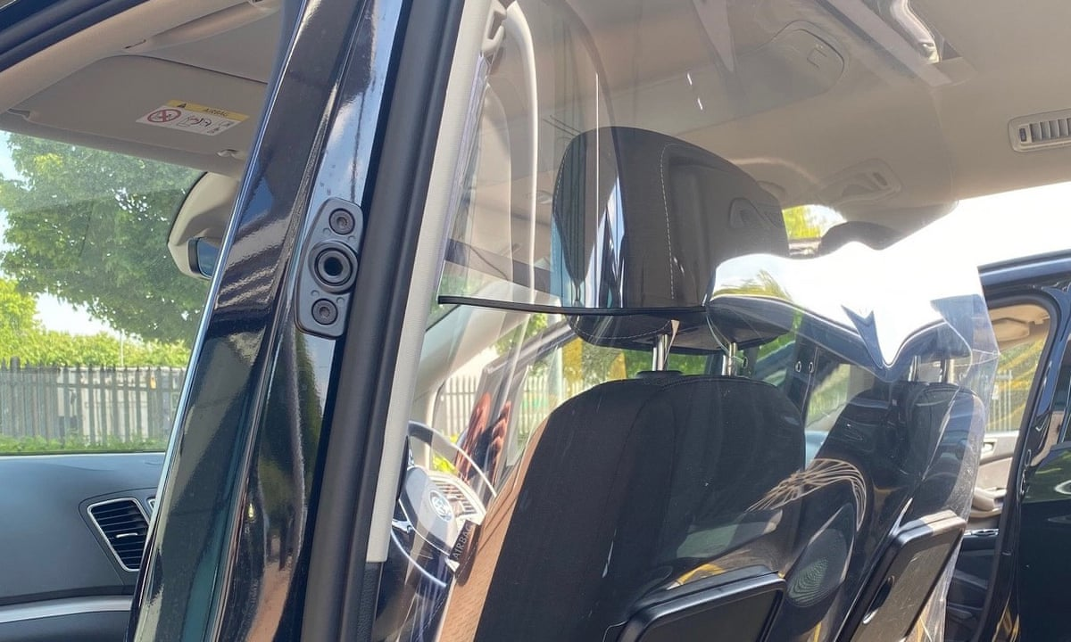

Figure -vehicle portioning

Source: Adapted from [11]

While the shield or partition system seemed to work effectively during this time, it came with its disadvantages which resulted in some taxi cab not adopting it as a standard for protection, these include:

* They are expensive to install
* They do not fit well in vehicles that are not purpose-built vehicles
* They limit driver-passenger interaction (and, therefore, possibly limit tips),
* They can interfere with heating and air conditioning circulation,
* They can lead to head injuries following sudden stops where passengers have not been wearing seat belts.

Such a system can be a good way to protect drivers from customers, but given a situation where the driver is the one who wants to rob the customer then the system can be a disadvantage. Also in a situation where the robbery uses the driver’s door to gain access to the driver then the system is rendered useless.

**Use of Cameras in the Vehicles**

In places like New York City, Chicago, and Sydney, Australia drivers are permitted to have cameras in their taxis in lieu of protective shields. The cameras take pictures of passengers at a regular time period and save them in a local storage.

Local authorities in the United Kingdom have permitted the use of CCTV cameras in licensed taxis as a way to protect the drivers and their valuable passengers. The cameras continuously record all the activities in the taxi and this has caused a lot of privacy issues as taxi drivers complain about their privacy.

The problem with this solution is that most passengers don’t like cameras, there are high chances that passenger’s privacy might be violated as the images are stored locally, the cameras might fail when someone hides their face while in the cab.

One issue with collecting such information is that of data protection. The system has to be in control of authorities who have the ability to follow Data protection law. This solution hence doesn’t allow everyone to use it, the use of such a system should be centralized to the local authorities.

**GPS devices**

The global positioning system (GPS) is a satellite based navigation system that enables accurate location updates in real time. The device is used in some vehicles to track the location of the taxi cabs. Tracking the location of a taxi cab helps in identifying the area or route that the driver used in case of any incident. This system on its own is not enough of a security feature, it works well when coupled with other systems such as the camera or the shield. The GPS is used mainly by ride sharing services in identifying the location of their vehicles for use in organizing trips.

**Alert systems**

Alert systems come is a number of ways but most safety alert systems make use of panic buttons to alert the authorities of first responders of any incidence in the taxi. This system is good safety feature when combined with other systems such GPS tracking upon alert.

**Uber Safety measures**

Uber has recorded many crimes related to taxis and this has led the company to consider improving its safety features, these features are discussed here.

Uber added a feature that enables riders to send a text message to local authorities with one tap that automatically populates trip details such as the make, model and license plate of their driver's car and their location information at the time they send the text, along with the option to type their emergency [12].

The challenge with such a system is that the passenger has to have their mobile phone all the time, which is not the case in Zimbabwe. Most people in Zimbabwe cannot adapt to such a system because a number of them don’t have mobile phones, those who have them might not be having power at that time and also the robbers might first of all take your phone before you get time to report.

Another feature is called Verify your Ride will give passengers a four-digit PIN to verbally provide to the driver before entering a vehicle. When their driver arrives, the PIN will pop up in the app, and the rider can read it to the driver. The driver will enter the PIN into their app. If it's correct, the rider will get a confirmation on their app, and the trip can begin [13]. This system is a good way of providing the right taxi for the customer, but in a situation where the driver’s phone is stolen, someone might pretend to be the driver and kidnap the customers.

Real-time driver ID checks is a system that ask drivers to submit a selfie periodically to confirm their identity, using [Microsoft](https://www.cnet.com/tags/microsoft/) technology to compare the selfie to their profile photo [13]. The technology is much helpful in identifying the driver, but if the robbers take the driver’s mobile device first and forcefully take selfies of the driver , then such a system will be no longer be helpful.

Another weakness that the Uber has is that it is mostly hardware based and does not provide devices that can be used in the car. The problem with basing their operations to the mobile app is that if someone manages to get the login details of a particular driver, they can receive trips and rob customers.Again, it is easy for customers to create accounts with details that are not theirs and hence are able to attack drivers and not enough evidence is left to start an investigation on the case.

**Lyft’s Safety Features**

Lyft is another ride sharing company like Uber, it has a number safety features which are all based on their lyft application, and these features include:

* **Get emergency help from ADT.**

If you ever feel uncomfortable or unsafe, you can discreetly connect with an ADT security professional right from your app. ADT can alert local authorities and share important ride details with them, like your vehicle's make and model, license plate number, and intended drop-off location.

* **Share your location in real time.**

The Lyft Driver app provides real-time ride tracking so you can share your location, route, and trip status with family and friends. You can rest assured that someone who cares about you knows where you are and where you're headed.

* **Predicting when you need help.**

If we notice something out of the ordinary about your ride, like it has stopped too soon or for an unusual amount of time, we may reach out to see if you need help. If needed, we’ll connect you with our Safety Team or directly with emergency assistance.

All of these features are app based, in case someone’s battery dies they are in danger, they provide nearly the same safety features as Uber.

### Solutions in Zimbabwe

In Zimbabwe there are few or no safety features put in place yet. The ride hailing services such as Vaya are not yet common to the greater population, most people are victimized while in a Honda fit or Toyota wish pirate taxis. Crimes take time to be dealt with, there is no adequate information related to these crimes and the only solution so far is avoiding such vehicles, which is not possible given the current transport situation in the country.

Statistics show that most of the drivers of these crime related cars are not criminals, there are a few that do crime once in a while and both passengers and drivers need a system that helps them know if they are really safe or not.

### Literature on the proposed solution

The proposed system makes use of fingerprint sensors to authenticate both the driver and the passengers at the beginning of a trip and at the end of a trip. The fingerprints details are stored in a secure database that is managed by the local authorities (The registrar).

Human fingerprints are widely used by law enforcement to match a suspect to a link for more than a 100 years now. They are used on our day to day activities to authenticate users when accessing their mobile phones, laptops and even access to building. Human fingerprints are detailed, unique, durable and difficult to alter hence they can be relied on for security measures.

### Characteristics Of fingerprints:

Fingerprints consists of friction ridges, which are raised lines and furrows, which are the valleys between those lines. The fingerprint ridge patterns are usually grouped into three types which have unique variations which include:

#### Loops:

Loops are prints that goes out and curves back to themselves to shape a loop. There are two types of loops which are

* Radial loops – which point towards the thumb or radius bone.
* Ulnar loops – which point towards the pinky or ulna bone.

The finger below shows the loops in a fingerprint.

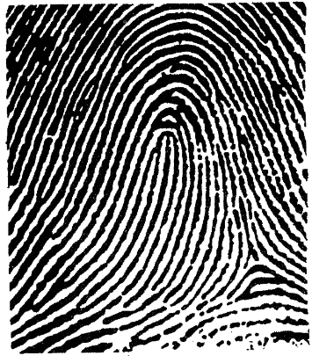

Figure fingerprint loops

Source: Adapted from [14]

#### Whorls

Whorls are circular or spiral ridge lines and they are divided into four groups:

* Plain-which are concentric circles
* Central pocket loop-a loop with a whorl at the end
* Double loop- two loops that create an S like pattern
* Central pocket loop – a loop with a whorl at the end

The figure below shows the whorls in the fingerprint

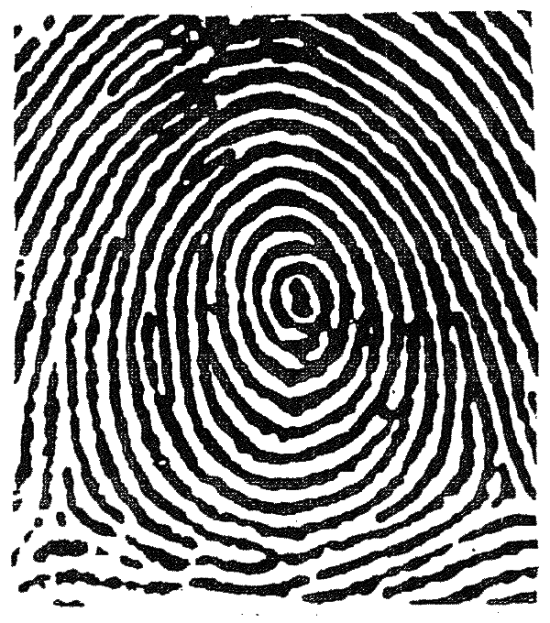

Figure - fingerprint whorls

Source: Adapted from [14]

#### Arches

Arches are a wave like pattern and are grouped into two categories which are tented arches and plain arches.

The figure below shows arches on fingerprints

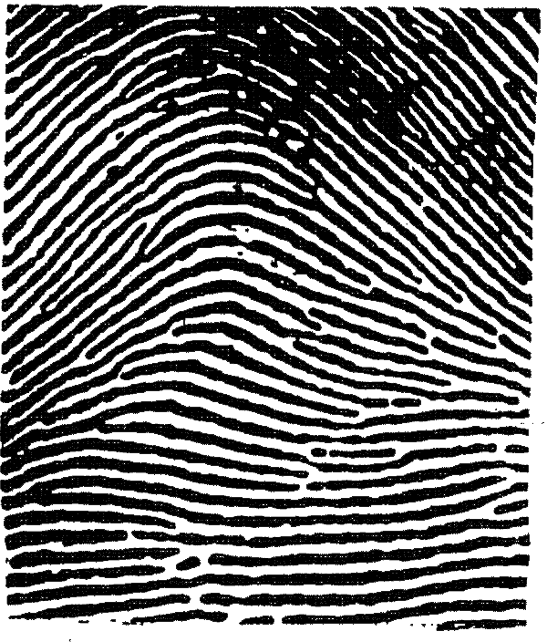

Figure - arches fingerprint

Source: Adapted from [14]

Loops makes about 60% of all fingerprint patterns, while whorls makes about 35% and arches about 5%.

### Literature on Fingerprint sensors

There are three main types of fingerprint sensors, which include:

#### Optical Scanners

Optical fingerprint sensors use a light emitting diode to illuminate the finger and an image of the ridges and valleys is taken and processed by the sensor.

Advantages of Optical Fingerprint sensors:

* Can be placed within capacitive displays and hence allows display fingerprint scanning.
* They are cheap to manufacture.

Disadvantages of Optical fingerprint sensors:

* + Can be easily spoofed
  + They are generally slower than other implementations of the sensor
  + They are bulky since they rely on led and a photosensitive element.

#### Capacitive Scanners

Capacitive scanners use electricity (uses a touch capacitive surface) to identify fingerprint patterns. When a finger is placed on the sensor, the capacitive surfaces measures the charge and generates an electric charge on places where the ridges are making contact with the surface and no electrical contact id determined in areas where there are valleys. The sensor uses this information to process a pattern of ridges and patterns.

Advantages

* They have high sensitivity
* They are faster than optical sensors

Disadvantages

* They cannot be placed on capacitive displays.

#### Ultrasonic Scanners

These scanners consist of an ultrasonic transmitter and receiver. An ultrasonic sound is sent to the finger and some of it is absorbed while some is reflected back depending on the ridges and valleys. The fingerprint processes the received signal and if enough signal is collected a 3D rendering of the surface can be created.

Advantages:

* Ultrasonic sensors can capture a highly detailed three-dimensional image
* They are more secure and more reliable than optical and capacitive sensors
* They can be used in in-display scanning.
* They can capture enough data even if the user has dirty hands.

Disadvantages:

* They are slower than capacitive sensors
* They are more expensive compared to the capacitive and ultrasonic sensors

## Conclusion

Both passengers and Customers are in danger of robbery, the only thing lacking is enough information to understand the crime. Most of the system put in place are software based and not much useful in some areas where access to mobile phones is not easy. Those that provide hardware related solutions fail to provide enough information in case of a crime. A system based on fingerprint scanning comes in to gather enough information in relation to the crime. Such a system can be integrated or built to include software solutions for those who can have access to mobile phones at the time.

# Methodology and design

## Introduction

This chapter dives into the methodology used for designing the proposed solution and also looks at the materials used on the design. The chapter uses block diagrams to show the interconnection between different components, the approach start on the general design of the system and narrows down to the specific on the subsystem designs of the system. The design approach is based on the functionalities and everything is integrated to build the overall system at the end.

## Materials used

### Raspberry Pi 4 board

The Raspberry Pi board is a series of small single boarded computers that was developed with the goal of creating a low-cost device that could enhance programming skills and understanding of the hardware to students and tech enthusiasts. The Raspberry pi is used in many areas as a computer as well as a development board to develop projects such as weather monitoring.

For the project a raspberry Pi 4 Model B was used. The model has a 1.5 GHz 64-bit quad core Cortex-A72 processor, Wi-Fi, Bluetooth 5 and 8 GB of RAM. The figure below shows a raspberry Pi 4 model B.

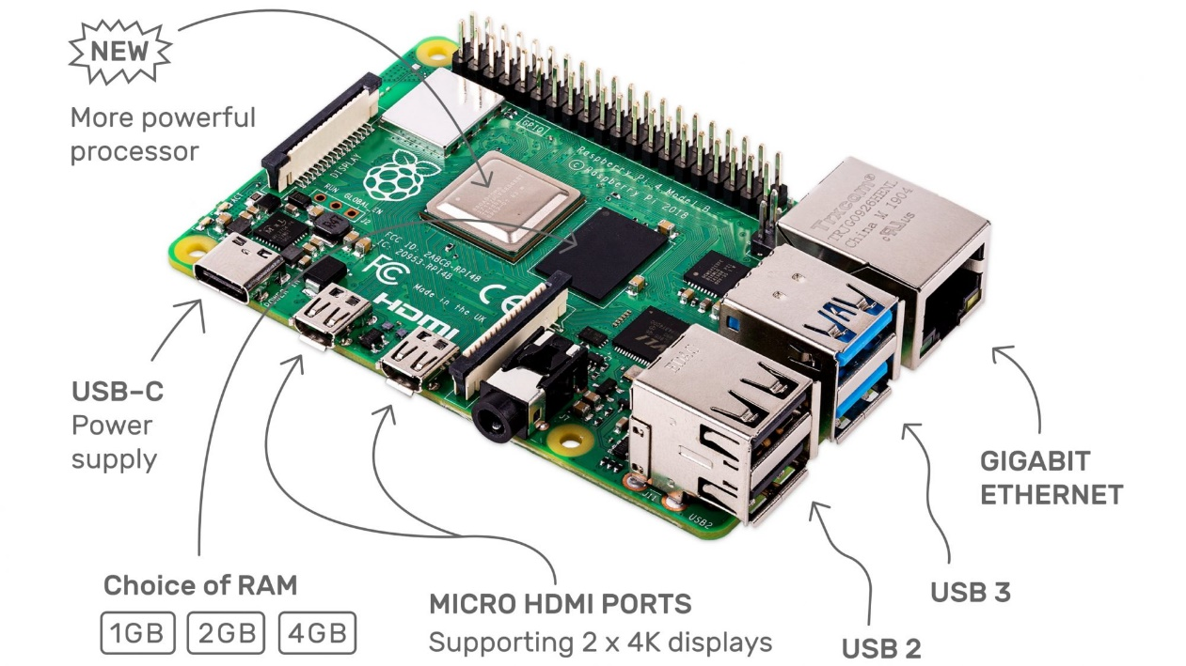

Figure -Raspberry Pi 4 model B

Source: Adapted from [15]

The Board contains other features such as the gigabit Ethernet, USB 2.0 and USB 3.0 ports and a dual monitor support via HDMI type D. The board is power hungry and is powered using USB-C port 5V at 3A [15].

### Raspberry Pi 7 inch display screen

The project made use of the raspberry pin 7 inch Touch screen display. The full color display screen has capacitive touch sensing capabilities is well suited for creating project that require a display and as well as input. The figure below shows the 7 inch display screen

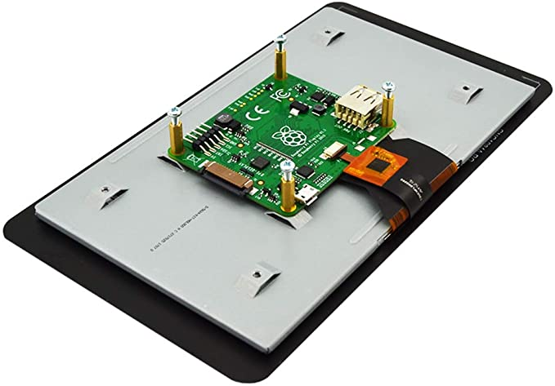

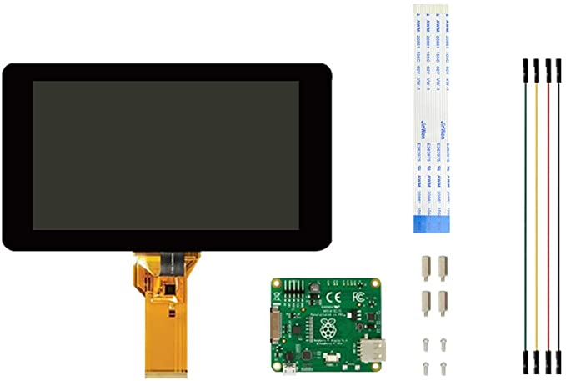

Figure -Raspberry pi 7 inch display screen

Source: Adapted from [15]

The screen uses the adapter board DSI ribbon cable 4 to transfer touch signals and the Ground and power cables are used for powering the screen. The screen requires 5v from the raspberry pi

### Fingerprint Sensors

.

The AS608 Optical Fingerprint

## For the Project a AS608 Optical Fingerprint Sensor is used

The figure below shows the AS806 Fingerprint sensor. It main features include:

* Supply voltage: 3.3V
* Maximum current supply: 60mA
* Resolution: 500dpi
* Max fingerprint imaging time: 1s
* Storage: 162 templates
* Baud rate: 9600, 19200, 28800, 38400, 57600 (default is 57600)

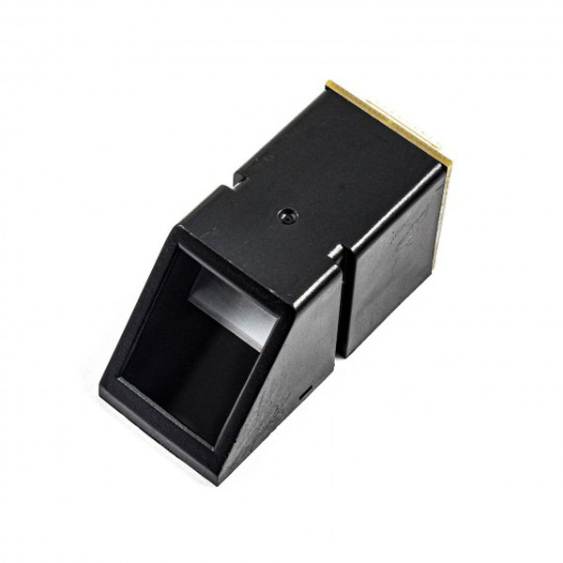

Figure 4: the AS608 Fingerprint sensor

Source: Adapted from [2]

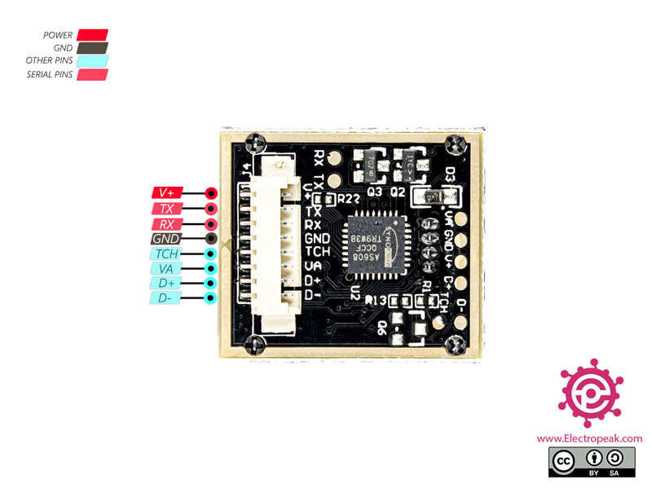

Figure 5: pin out diagram for the AS608 optical fingerprint sensor

Source: Adapted from [2]

The AS608 Fingerprint sensor has 4 useful pins as shown in the figure above:

* **V+**: Module power supply – 3.3V to 5V
* **TX**: Serial Transmitter
* **RX:**Serial Receiver
* **GND**: Ground

The working Principle of the fingerprint sensor:

The fingerprint module exposes two API processes which are:

* Fingerprint registration process

During the registration process two fingerprints are captured for the same fingerprint and the image is processed two times and generate a fingerprint template and store it in one of the 127 locations.

* Fingerprint matching process

The matching process is divided into 1:1 and 1:N processes. During the 1:1 matching process, the fingerprint is captured by the sensor and a template generated which will be compared to a specific template stored in the module, the process returns true for successful match and false for failed matching. During the 1:N the fingerprint is captured and a template generated that is used to search the whole database for the match will the closest score, success gives a return of true and failure is signalled by false. [3]

Reading the Fingerprint templates:

The sensor exposes another API used to read the fingerprint data from the registers and transfer them to the microcontroller via UART communication. The read data has 512bytes and below is the data from a thumb fingerprint formatted in hexadecimal form:



### GPS module

### Node.js

### MongodB database

### React.js

## System design

### System overview design

#### Overall system design

#### Hardware connection

#### The Server side

#### The database

#### The Front end

#### Communication Protocols

Discuss the front and the back end as well as the connection of the hardware components

### Registration

#### Registration of Admins and their role

#### Registration of the driver

#### Ride or Trip beginning

#### Trip End

#### Panic or emergency

#### Searching for Statistics on crimes

#### Handling a crime

### Overall System Block Diagram

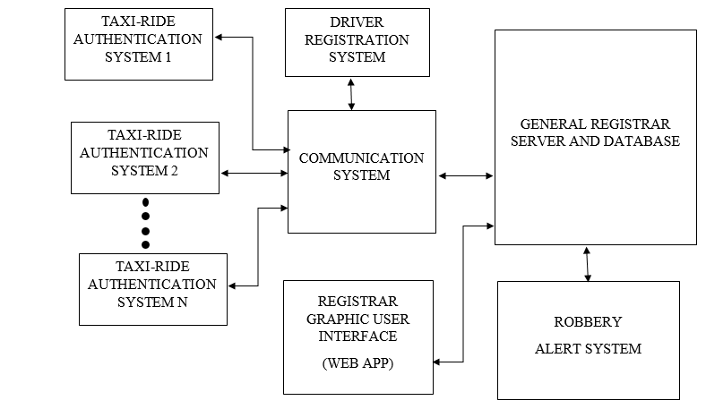

Figure 7-overall system block diagram

Figure 1 above shows the overview of the whole system, the system will be divided into several subsystems that will be communicating through the internet (IoT). The design of the subsystems will be as follows.

## Design of System Modules

The system will be designed using a modular iterative agile approach, where designs in the module will be feature driven and testing will be done after addition of every feature.

### Taxi-ride authentication system

This is the system that will be mounted on every taxi and will be responsible for capturing the passenger and driver details.

The design of this subsystem will consist of the microcontroller board, input sensors (finger print and heartbeat sensors, panic buttons, pressure sensor) and output devices (LCD screen, actuators for opening and closing the door)

The following block diagram shows how the parts of the whole system will be connected:

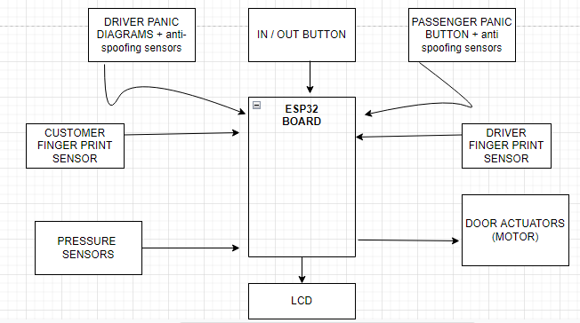

Figure 8-taxi ride authentication system

The following shows the flow chart for the code that will run in the microprocessor:

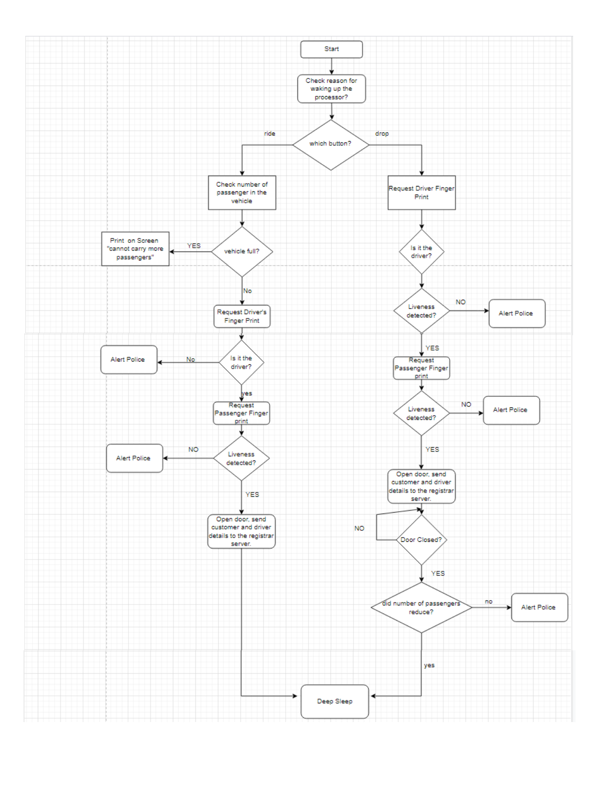

Figure 9-taxi-ride-flowchart

Figure 3 above shows the logical flow of the code that will be running in the microprocessor. The processor will be in deep sleep most of the times and an external signal inform of push buttons will wake the processor up on which the program determines which push button was pushed, if the driver pushes the button for riding, the code for picking the passenger runs but if it’s the other push button, which is for dropping a passenger, then the corresponding program runs.

In case of emergencies during a trip, the panic buttons are used to trigger interrupts which run and alert the police of whether the driver or passenger has an emergency. The design for the panic buttons is shown by the interrupts below.

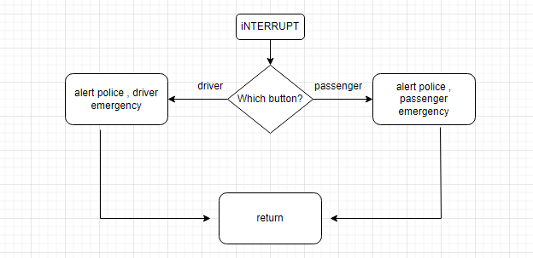

Figure 10-interrupt service routine for panic buttons

### Design of the Server and database

To understand the design of the server system, users of the system must first be identified, their roles and how they interact with the system.

The server will be heart of the system, it will control all the activities of the system, serve data and also present data to the database management system (DMS).

The users of the system will be as follows:

* The Registrar Super administrator

This will include a person or group of people with super privileges to the system, they can add and delete Registrar Admins and Third Party Admins. They Have access to all the information in the database.

* The Registrar Administration

This group of Administrators have Privileges to a certain level. They can only access the part of the system that is related to their work. For Example an admin responsible for registering and de-registering taxi drivers. They can add and delete only what is related to their line of work and are responsible for all their actions. They cannot add or delete any administrators.

* Third Party Admins

This group of people include people who might need access to the information related to taxis. Their privileges are limited to reading information only, they cannot add or delete anything. They have access to the non-vital part of the driver’s and passenger’s information. These include people who may want statistics related to taxi robbers and people like the low level police who might to use the information in case of a crime.

The following shows the use case diagrams for the different users of the system

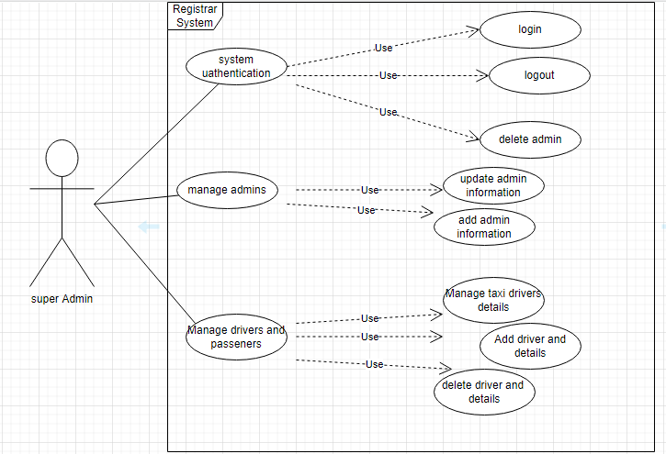

Figure 11-super user usecase diaram

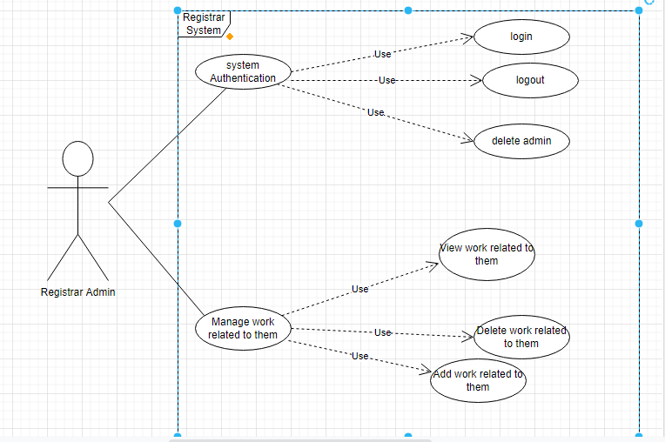

Figure 12-registrar admin usecase

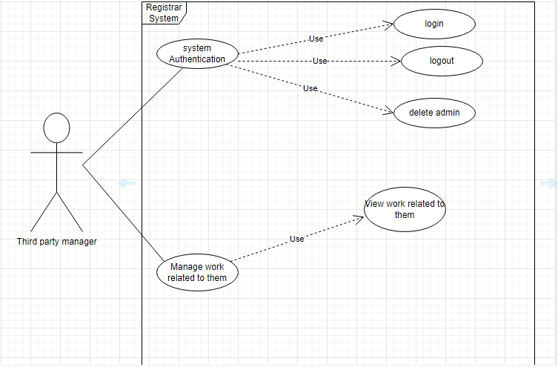

Figure 13-third party registrar usecase

#### The server Architecture

To understand the architecture of the server, the endpoint and related actions need to be well defined.

The following table describes the end points and the request and queries made to or by the client.

|  |  |
| --- | --- |
| **URL** | **ACTION** |
| */super/access/* | Handles login, log out |
| */super/taxi?action=””&vehicle_id=””* | Views data about the taxi depending in the parameters. |
| */super/driver?action=””&vehicle_id=””* | Handles driver’s information such as view log, delete, add driver |
| */super/admin?action=””* | Handles actions such related to admins, adding admin removing admin, editing admin information |
| */registrar?* | Handles events depending on parameters |
| */thirdparty?params* | Handles viewing information depending on parameters |
| */super/search/finger_print_id* | Use finger print to search information about driver or passenger |
| */super/track/vehicle_id* | Start tracking vehicle in real time. |
| */taxi/vehicle_id/pick_up* | Add driver and passenger details during pickup |
| */taxi/vehicle_id/drop* | Signal driver and passenger separation. |
| */taxi/vehicle_id/alert* | Signal an alert , with a message as part of the request body |

Node.js will be used for server side scripting. Node.js is good for building real time applications, making the language suitable for building the server. The server will also handle connections to the database as well as uploading and reading information from the database.

The server exposes REST API to the Taxi ride hardware as well as to the Single page application

The following shows the flowchart for the server design in handling requests and connecting to the database.

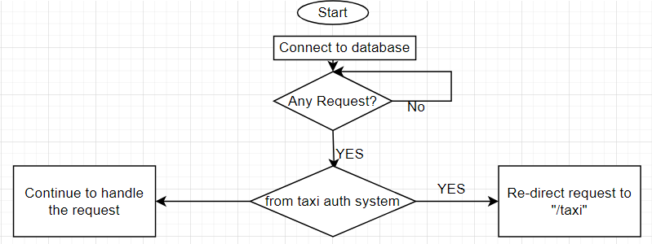

Figure 14-server request handling

The following shows how the server will handle differentiating different admin types:

Each and every route handling function will have a callback function that will check the type of admin before responding accordingly.

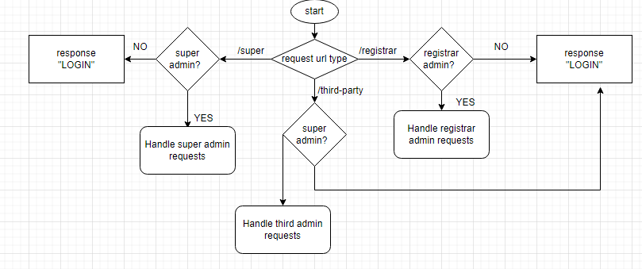

Figure 15-differentiating admins

The following diagrams shows the design for handling queries to the database in the server.

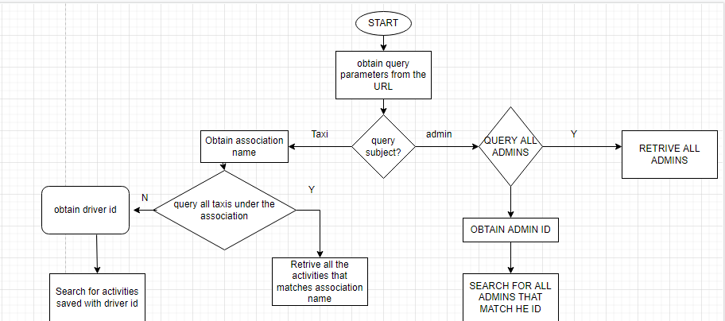

Figure 16-Flow chart showing how the server will handle searches

The following flow chart illustrates how the server will be used during investigations

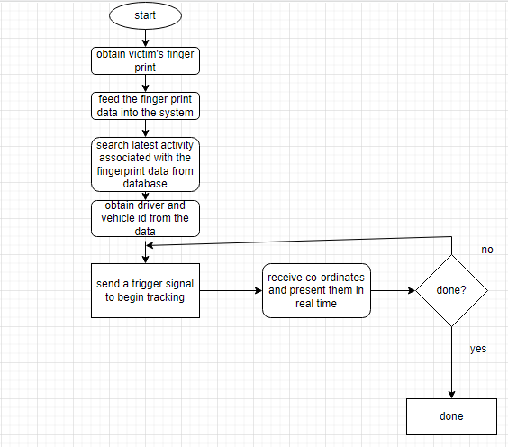

Figure 17-obtaining investigation data

The Following designs show how the request from the taxi ride will be handled

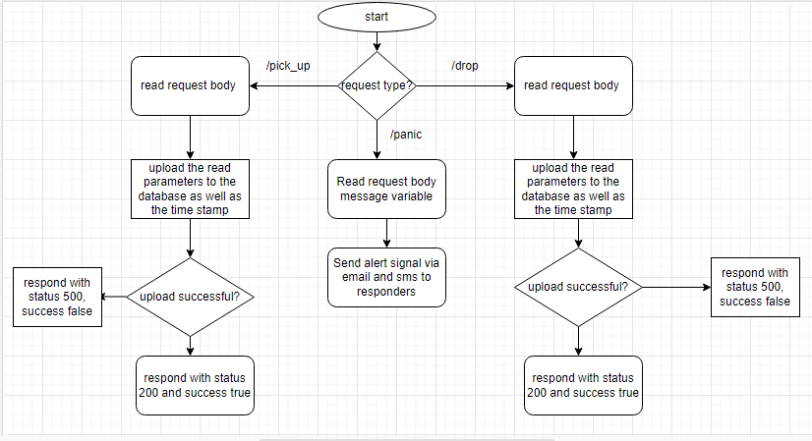

Figure 18-the server design for handling request for taxi ride

As stated above, the design of the system will be iterative and hence the design will be modified as the actual system is being implemented, the above sketches mainly show the skeleton of the system, more features will be added as the system is being implemented.

The front end of the system will be implemented using react.js. React is a free and open-source front-end JavaScript library for building user interfaces based on UI components. It is maintained by Meta (Facebook) and a community of individual developers and companies. [15]

### Design of the database

MongoDB will be used for database management. MongoDB is a source-available cross-platform document-oriented database program. Classified as a NoSQL database program, MongoDB uses JSON-like documents with optional schemas. Mongoose will be used to create a connection between MongoDB and Express.

The database will be responsible for storing all the information related to the system, the following diagrams show how the database will be implemented.

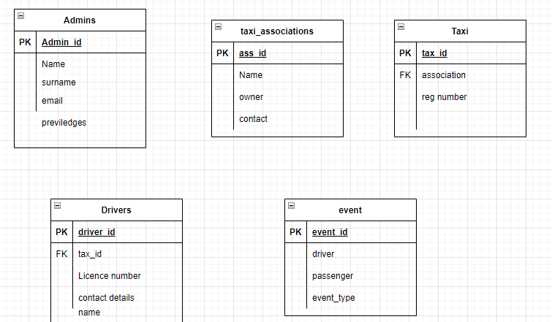

Figure 19-database design

List of acquired components

* ESP32-WROVER-B
* Esp32 wroom32
* LCD
* RESISTORS
* JUMPERS
* MOTORS

# References

|  |  |
| --- | --- |
| [1] | H. Ndhlovu, "Tuverl," Tuverl Inc, 2020. [Online]. Available: https://www.tuverl.com/blog/a-look-at-public-transportation-in-zimbabwe/. [Accessed 19 December 2021]. |
| [2] | "CBS NEWS AND STATIONS," CBS, 6th January 2022. [Online]. Available: https://www.cbsnews.com/chicago/news/police-alert-armed-robberies-carjackings-rideshare-drivers-south-austin-west-garfield-park/. [Accessed Thursday May 2022]. |
| [3] | Nyathi, "Crackdown on pirate taxis, vendors intensifie," Herald, 04 April 2022. [Online]. Available: https://www.herald.co.zw/crackdown-on-pirate-taxis-vendors-intensifies/. [Accessed Thursday May 2022]. |
| [4] | A. Chaparadza, "How Safe Is It To Use Vaya Africa," TechZim, 20 November 2018. [Online]. Available: https://www.techzim.co.zw/2018/11/how-safe-is-it-to-use-vaya-africa/. [Accessed 26 May 2022]. |
| [5] | M. J. Smith, "Office of Justice Programs," Office of Justice Programs, April 2005. [Online]. Available: https://www.ojp.gov/ncjrs/virtual-library/abstracts/robbery-taxi-drivers. [Accessed Sunday 19th December 2021]. |
| [6] | "Conserve Energy Future .," [Online]. Available: https://www.conserve-energy-future.com/benefits_of_public_transportation.php#:~:text=Public%20transportation%20is%20a%20form,dominate%20public%20transportation%20between%20cities.. [Accessed 27 May 2022]. |
| [7] | Chan, Nelson & Shaheen, Susan, Ridesharing in North America: Past, Present, and Future.Transport Reviews, vol. J, (2012). |
| [8] | Turvel, "A look At Public Transportation In Zimbabwe," turvel.com, 16 February 2020. [Online]. Available: https://www.tuverl.com/blog/a-look-at-public-transportation-in-zimbabwe/. [Accessed 28 May 2022]. |
| [9] | "REPORTED LIST OF INCIDENTS INVOLVING UBER AND LYFT," Atchison Arts, 26 July 2022. [Online]. Available: https://www.atchisontransport.com/blog/reported-list-of-incidents-involving-uber-and-lyft/. [Accessed 28 May 2022]. |
| [10] | M. Phiri, "Honda Fit has become the vehicle of choice for criminals in Zimbabwe," Mail and Guardian , 21 April 2022. [Online]. Available: https://mg.co.za/africa/2022-04-21-honda-fit-has-become-the-vehicle-of-choice-for-criminals-in-zimbabwe/. [Accessed 29 May 2022]. |
| [11] | A. Lee, "Addison Lee and Uber to install partition screens in cabs," The Gurdian, 2020. [Online]. Available: https://i.guim.co.uk/img/media/b455eaf376a2dcae4bd9188b4f0d02a0ef00d15d/0_198_1263_758/master/1263.jpg?width=1200&quality=85&auto=format&fit=max&s=8bafbf299c4382f46e1d3a4328facab5. [Accessed 29 May 2022]. |
| [12] | A. Benjamin, "CNET TEC," Cnet, Nov 2016. [Online]. Available: https://www.cnet.com/tech/mobile/how-ubers-new-safety-features-want-to-fight-murders-kidnappings-and-other-horrible-things/?ftag=COS-05-10aaa0a. [Accessed 2021 Dec 2021]. |
| [13] | C. Net, "cnet.com," C Net, [Online]. Available: https://www.cnet.com/tech/mobile/how-ubers-new-safety-features-want-to-fight-murders-kidnappings-and-other-horrible-things/. [Accessed 10 11 2021]. |
| [14] | " Writing and research," [Online]. Available: https://libguides.sait.ca/images/citing. |
| [15] | "wikipedia," Wikipedia, [Online]. Available: https://en.wikipedia.org/wiki/React_(JavaScript_library). [Accessed 20 December 2021]. |
| [16] | S. Chow, "MIT Technology Review," © 2021 MIT Technology Review, 2021. [Online]. Available: https://www.technologyreview.com/2021/12/16/1042603/uber-driver-murdered-gig-economy/. |
| [17] | AllAfrica, "allafrica.com," All Africa, [Online]. Available: https://allafrica.com/stories/201311050080.html. [Accessed 10 November 2021]. |
| [18] | "transcom.gov.zw," transcom.gov.zw, [Online]. Available: http://www.transcom.gov.zw/?page_id=374. [Accessed 10 November 2021]. |
| [19] | "uber.com," uber, [Online]. Available: https://www.uber.com/br/en/ride/safety/rider-safety-features/. [Accessed 10 november 2021]. |
| [20] | [Online]. |